Given a stratified media (where $ε=ε\left(z\right)$ and $μ=μ(z)$ where the z direction is along the depth of the material). Maxwell’s equations, when applied to this situation end up giving a solution of the form

$$E_{x}=U\left(z\right)e^{i\left(k_{0}αy-ωt\right)}, \\ H_{y}=V\left(z\right)e^{i\left(k_{0}αy-ωt\right)}, \\ H_{z}=W\left(z\right)e^{i\left(k_{0}α-ωt\right)},$$

and U, V, and W are related by

$$\frac{dV}{dz}=V'=ik_{0}\left[αW+εU\right], \\ \frac{dU}{dz}=U'=ik_{0}μV, \\ αU+μW=0.$$

This leads to the coupled equation (which is of the same form as the transmission line equations)

$$\left\{\begin{aligned}U'=ik_{0}μV, \\ V'=ik_{0}\left(ε-\frac{α^{2}}{μ}\right)U,\end{aligned}\right.$$ where

$k_{0}=\frac{ω}{c}=\frac{2π}{λ_{0}}$, $n^{2}=εμ,$

And for a homogenous wave

$α=n\sin{θ},$ $α=constant$.

Which, when given media with constant *ε* and *μ* that the uncoupled equations are

$$\frac{d^{2}U}{dz^{2}}+\left(k_{0}^{2}n^{2}\cos^{2}{θ}\right)U=0 \\ \frac{d^{2}V}{dz^{2}}+\left(k_{0}^{2}n^{2}\cos^{2}{θ}\right)V=0$$

This is all that is needed to develop the desired matrix form given two arbitrary sets of coupled equations, that is,

$V_{1}U_{2}^{'}-U_{1}^{'}V_{2}=0$ and $U_{1}V_{2}^{'}-V_{1}^{'}U_{2}=0$

lead to

$$\frac{d}{dz}\left(U_{1}V_{2}-U_{2}V_{1}\right)=0$$

which means that *D*, the determinant of a matrix as follows, is constant.

$$D=\left|\begin{matrix}U_{1} & V_{1} \\ U_{2} & V_{2}\end{matrix}\right|$$

Next, we make somewhat premonitory choice of setting $D=1$ by letting the particular solutions of *U* and *V* be:

$$\left\{\begin{aligned}U_{1}=f\left(z\right), U_{2}=F\left(z\right), \\ V_{1}=g\left(z\right), V_{2}=G\left(z\right), \end{aligned}\right.$$

where $f\left(0\right)=G\left(0\right)=0$, $F\left(0\right)=g\left(0\right)=1$, so that for

$U\left(0\right)=U_{0}$ and $V{\left(0\right)=V}_{0}$,

$$\left\{\begin{aligned}U=FU_{0}+fV_{0} \\ V=GU_{0}+gV_{0}\end{aligned}\right.$$

Giving $Q=NQ_{0}$, which can be rearranged to $Q_{0}=MQ$ where

$$Q=\left[\begin{aligned}U\left(z\right) \\ V\left(z\right)\end{aligned}\right], Q_{0}=\left[\begin{aligned}U_{0} \\ V_{0}\end{aligned}\right], N=\left[\begin{matrix}F(z) & f(z) \\ G(z) & g(z)\end{matrix}\right], M=N^{-1}=\left[\begin{matrix}g(z) & -f(z) \\ -G(z) & F(z)\end{matrix}\right].$$

Importantly, $\left|N\right|=\left|M\right|=1$ (***M*** and ***N*** are unitary) and any product of a sequence of these has the same property. ***M*** is called the characteristic matrix of the medium and the main focus of this work.

Here is where real usefulness begins. For a *homogeneous dielectric film*, that is one which has ε, μ, and consequently *n* as constant, and *θ* as the angle to the *z*-axis,

$$M(z)=\left[\begin{matrix}cos⁡(k_{0}nz\cos{θ}) & -\frac{i}{p}sin⁡(k_{0}nz\cos{θ}) \\ -ip sin⁡(k_{0}nz\cos{θ}) & cos⁡(k_{0}nz\cos{θ})\end{matrix}\right]$$

Where

$$p=\sqrt{\frac{ε}{μ}}\cos{θ}.$$

***M*** and ***N*** are inverses and can be separated into a series of multiplied component matrices, each of the form ***M­j*** or ***Nj*** (which are also inverses of each other) and representing the material properties of the *j*th layer, of each of the layers of material in between boundary *a* and boundary *b* as well as the layer after the final boundary. That is for a wave which makes a direct path from *a* to *b*,

$$\begin{aligned}Q_{a}=MQ_{b} \\ M=M_{a+1}M_{a+2}…M_{b-1}M_{b}\end{aligned}$$

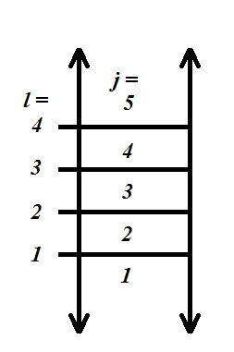(note that each successive ***M*** matrix is multiplied to the right where ***N*** matrices would be multiplied to the left). For layers of small thickness, *hj*, the following approximations can be used:

$$M_{j}=\left[\begin{matrix}1 & -\frac{i}{p_{j}}k_{0}n_{j}h_{j}\cos{θ_{j}} \\ -ip_{j}k_{0}n_{j}h_{j}\cos{θ_{j}} & 1\end{matrix}\right]$$

$$N_{j}=\left[\begin{matrix}1 & \frac{i}{p_{j}}k_{0}n_{j}h_{j}\cos{θ_{j}} \\ ip_{j}k_{0}n_{j}h_{j}\cos{θ_{j}} & 1\end{matrix}\right]$$

$$p_{j}=\sqrt{\frac{ε_{j}}{μ_{j}}}\cos{θ_{j}}$$

The fields at the boundaries are then given as $$\left\{\begin{aligned}U_{a}=A+R, U_{b}=T, \\ V_{a}=p_{a}\left(A-R\right), V_{b}=p_{b }T,\end{aligned}\right.$$

Where *A, R,* and *T* are the amplitudes of incident, reflected, and transmitted waves respectively.[1] This means that $$Q_{a}=\left[\begin{aligned}A+R \\ p_{a}(A-R)\end{aligned}\right], Q_{b}=\left[\begin{aligned}T \\ p_{b+1}T\end{aligned}\right]$$

If instead we are interested in the coefficients of reflection, *r*, and transmission, *t*, then we can instead use

$$\frac{Q_{a}}{A}=\left[\begin{aligned}1+r \\ p_{a}(1-r)\end{aligned}\right], \frac{Q_{b}}{A}=\left[\begin{aligned}t \\ p_{b+1}t\end{aligned}\right]$$

It is the coefficient of reflection that we are most concerned with here.

*Two Mediums with Reflection:*

Of interest is the case of a single boundary layer as shown below. In this case $Q_{a}=Q_{b}$ so $$\left[\begin{aligned}{|E}_{y}\left(z\right)| \\ {|H}_{x}\left(z\right)|\end{aligned}\right]=\left[\begin{aligned}A+R \\ p_{a}(A-R)\end{aligned}\right]=\left[\begin{aligned}T \\ p_{b+1}T\end{aligned}\right] or equivilently \left[\begin{aligned}1+r \\ p_{a}(1-r)\end{aligned}\right]=\left[\begin{aligned}t \\ p_{a+1}t\end{aligned}\right]$$

If second layer is air, and *R1, q­air,* and *q­1* are known, *T* and *A* are solvable by: $$Q_{1}=Q_{1} \\ \left[\begin{aligned}A_{1}+R_{1} \\ p_{1}\left(A_{1}-R_{1}\right)\end{aligned}\right]=\left[\begin{aligned}T_{1} \\ p_{air}T_{1}\end{aligned}\right]→\left\{\begin{aligned}A_{1}+R_{1}=T_{1} \\ p_{1}A_{1}-p_{1}R_{1}=p_{air}T_{1}\end{aligned}\right.→\left\{\begin{aligned}T_{1}-A_{1}=R_{1} \\ p_{air}T_{1}-p_{1}A_{1}=-p_{1}R_{1}\end{aligned}\right. \\ \left[\begin{matrix}1 & -1 \\ p_{air} & -p_{1}\end{matrix}\right]\left[\begin{aligned}T_{1} \\ A_{1}\end{aligned}\right]=\left[\begin{aligned}R_{1} \\ {-p}_{air}R_{1}\end{aligned}\right]→\left[\begin{aligned}T_{1} \\ A_{1}\end{aligned}\right]={\left[\begin{matrix}1 & -1 \\ p_{air} & -p_{1}\end{matrix}\right]}^{-1}\left[\begin{aligned}R_{1} \\ {-p}_{air}R_{1}\end{aligned}\right]$$

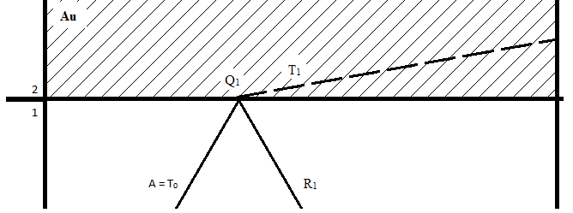

If the second layer is totally reflective (for instance if it is made of an ideal metal) then there is no transmitted wave, that is, $T=0$ and as a consequence $t=0, r=-1$, and *pb+1* is ill-defined.

*Three Mediums with Reflection:*

With more layers this reflection causes problems because it forces the field to be zero in the middle and these values propagate through all other equations. As such, I propose a work around. The goal of this is to relate the two portions of the reflection, incident and reflected:

$$N_{2}Q_{1}=Q_{2}$$

$$Q_{2}^{'}=P_{refl}Q_{2} \\ Q_{2}^{'}=M_{2}Q_{3}$$

***Prefl*** is a matrix which describes the effects of the reflection from the third layer. For a first approximation this can be negative one times the identity matrix.[2]

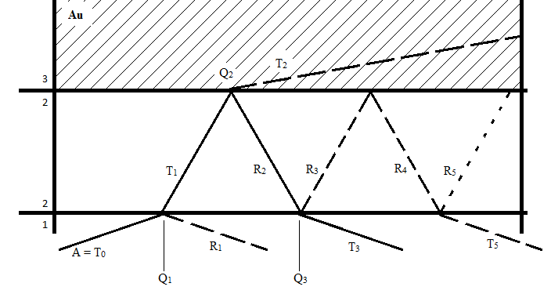Because the wave travels back through the same media with parallel surfaces $(p_{2, N}=p_{2,M})$:

$${N_{2}P_{refl}^{-1}N}_{2}Q_{1}=Q_{3} or M_{2}P_{refl}M_{2}Q_{3}=Q_{1}.$$

Both of the surface matrices used are defined and can be easily measured, hopefully avoiding the problems with focusing on the reflection point itself. Even better, the material properties of the middle medium might be solvable given the proper information.

$${{(N}_{2}P_{refl}^{-1}N}_{2})Q_{1}=Q_{3} \\ \left[\begin{matrix}n_{11} & n_{12} \\ n_{21} & n_{22}\end{matrix}\right]\left[\begin{aligned}1+r_{1} \\ p_{1}(1-r_{1})\end{aligned}\right]=\left[\begin{aligned}t_{3} \\ p_{1}t_{3}\end{aligned}\right]$$

(by similar argument as above $p_{1}=p_{3+1}$ which is defined by the medium which the transmitted wave at ***Q3*** propagates into and *nab* is just the matrix element for that position)

This seems to be where the matrices (and their elements) must be broken down into specific physical and geometrical pieces. This system of equations can be used to find *t3* and *r1* in terms of *ε2*.

This situation is mimicked in the relation between ***Q3***­ and ***Q­5***­ so

***Prefl2*** is the reflection matrix for the boundary between the unknown media and the silicon

It can be extended so that for any number, *l*, of reflections from the gold:

$$Q_{l}={P_{refl2}^{-1}\left({{P_{refl2}N}_{2}P_{refl}^{-1}N}_{2}\right)}^{l}Q_{1}$$

$$\left[\begin{aligned}t_{l} \\ p_{1}t_{l}\end{aligned}\right]={\left[\begin{matrix}n_{11} & n_{12} \\ n_{21} & n_{22}\end{matrix}\right]}^{l-1}\left[\begin{aligned}1+r_{1} \\ p_{1}(1-r_{1})\end{aligned}\right]$$

To simplify let’s set $G=\left({{P_{refl2}N}_{2}P_{refl}^{-1}N}_{2}\right)$**.**

We already have the thick case solved. From there we have to get a formula for one bounce off of gold, then three and so on.

First we look at the initial incidence, i.e. where the light first hits the boundary between the silicon and the sample. At this point $Q_{a}=Q_{b}=Q_{1}$ and the side which the light is incident from and reflected on is in the silicon so:

$$\left[\begin{aligned}1+r_{1} \\ p_{1}\left(1-r_{1}\right)\end{aligned}\right]=\left[\begin{aligned}t_{1} \\ p_{2}t_{1}\end{aligned}\right]→\left\{\begin{aligned}1+r_{1}=t_{1} \\ p_{1}\left(1-r_{1}\right)=p_{2}t_{1}\end{aligned}→\frac{p_{2}}{p_{1}}=\frac{1-r_{1}}{1+r_{1}}\right. or r_{1}=\frac{p_{1}-p_{2}}{p_{1}+p_{2}}$$ Importantly this makes $R_{1}=A_{1}\frac{p_{1}-p_{2}}{p_{1}+p_{2}}$. This insight on a single reflection will prove valuable.[3]

Now, if we assume only one reflection from gold,

$$R_{tot}=R_{1}+T_{3} \\ {P_{refl2}^{-1}\left(G\right)}^{2}\left[\begin{aligned}A_{1}+R_{1} \\ p_{1}\left(A_{1}-R_{1}\right)\end{aligned}\right]=\left[\begin{aligned}T_{3} \\ p_{1}T_{3}\end{aligned}\right] \\ {P_{refl2}^{-1}\left(G\right)}^{2}\left[\begin{aligned}A_{1}+R_{1} \\ p_{1}\left(A_{1}-R_{1}\right)\end{aligned}\right]+\left[\begin{aligned}R_{1} \\ p_{1}R_{1}\end{aligned}\right]=\left[\begin{aligned}T_{3} \\ p_{1}T_{3}\end{aligned}\right]+\left[\begin{aligned}R_{1} \\ p_{1}R_{1}\end{aligned}\right]=\left[\begin{aligned}R_{tot} \\ p_{1}R_{tot}\end{aligned}\right]$$

Now the right side is known and the left side can be made purely a function the variable of our choice (any of *n2, ε2,* cos *θ2,* or *q2* can be used).

For multiple reflections from gold,

$${P_{refl2}^{-1}\left(G\right)}^{L}\left[\begin{aligned}A_{1}+R_{1} \\ p_{1}\left(A_{1}-R_{1}\right)\end{aligned}\right]=\left[\begin{aligned}T_{L+1} \\ p_{1}T_{L+1}\end{aligned}\right]$$

$$P_{refl2}^{-1}\left(G+G^{2}+…+G^{L}\right)\left[\begin{aligned}A_{1}+R_{1} \\ p_{1}\left(A_{1}-R_{1}\right)\end{aligned}\right]+\left[\begin{aligned}R_{1} \\ p_{1}R_{1}\end{aligned}\right]=\left[\begin{aligned}R_{tot} \\ p_{1}R_{tot}\end{aligned}\right]$$

Finding ***GL*** can be made faster by diagonalizing the ***G*** matrix.

1. Up to this point is a summary of M. Born and E. Wolf, *Principles of Optics. 6th ed.* (Pergamon Pres, Inc., New York), pp. 51-60.
2. I never really explored this, as we changed methods before I could. I think there also may need to be some matrix to account for the fact that the z axis (and consequently the x axis) changes direction. Because $Q(z)=\left[\begin{aligned}{|E}_{x}\left(z\right)| \\ {|H}_{y}\left(z\right)|\end{aligned}\right]$, I think a multiplication of $\left[\begin{matrix}-1 & 0 \\ 0 & 1\end{matrix}\right]$ is needed. This should give the proper direction vector. Also of note is that $N\left(-z\right)= N{\left(z\right)}^{-1}= M(z)$. I will continue my derivation using the above but these should be considered further.
3. Similar analysis shows that $r_{refl2}=\frac{p_{2}-p_{1}}{p_{2}+p_{1}}$ and perhaps $P_{refl2}=r_{refl2}I$ or something similar from logic parallel to that of the previous footnote.